**Calculator With History Feature**

A calculator, created using HTML, CSS and JavaScript, with a history feature to show past calculations.

The calculator allows to perform following functions-

• Basic Operations: Addition, subtraction, multiplication, division, remainder

• Trigonometric functions: sin(), cos(), tan()

• Square, cube, squareroot, cuberoot, factorial, value of π

[](https://github.com/vanshika-singh518/CalculatorWithHistoryFeature/blob/main/calculator-with-history-feature.png)

**Features of the Calculator**

• Numbers from 0 to 9

• Decimal calculations are also allowed

• History feature with scrollbar to see past calculations

• **AC :**All Clear button to clear the display screen

• **CE :**Clear button for backspace

• **= :**To evaluate the expression

• **+ :**To perform addition

• **- :**To perform subtraction

• **\* :**To perform multiplication

• **/ :**To perform division

• **% :**To calculate remainder

• **x! :**To calculate the factorial of given number

• **√ :**To calculate squareroot

• **∛ :**To calculate cuberoot

• **x2 :**To calculate square of given number

• **x3 :**To calculate cube of given number

• **π :**Gives the value of pi

• **sin(value) :**Returns the sine of a number, where value is a number given in radians.

• **cos(value) :**Returns the cosine of a number, where value is a number given in radians.

• **tan(value) :**Returns the tangent of a number, where value is a number given in radians.

[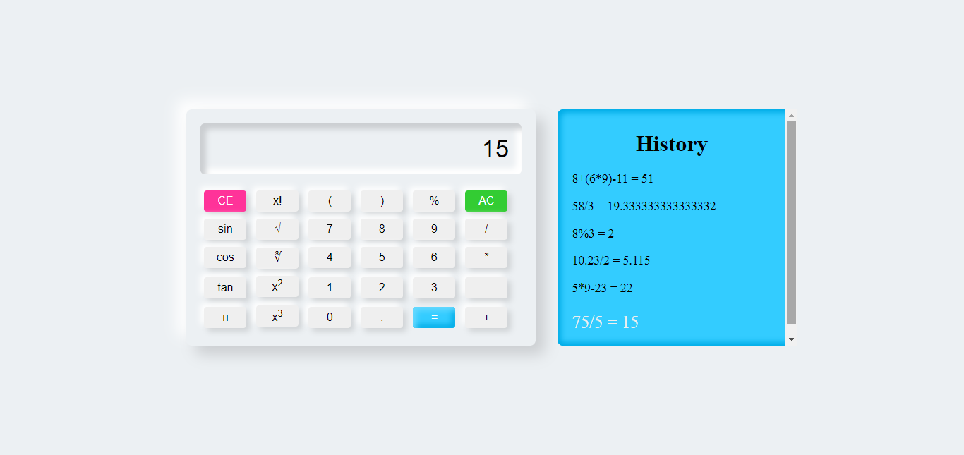](https://user-images.githubusercontent.com/83200847/138139134-eed58c98-4751-490d-ade3-9b1e45790f10.png)